Introduction

Most big businesses do drug tests so they know there employees are behaving within the law. They test for many drugs such as steroids, cannabis cocaine and heroin. Effects of these drugs can only be detected for a few hours after use but you can still detect them with a urinalysis. This works because you can detect the drugs metabolites (biochemically mutated compounds left in the body) (Wikipedia, 2015). The way we can detect these drugs in a urine sample is with a process called GC-MS (gas chromatography-mass spectrometry), which is a two part process.
Gas Chromatography


Gas chromatography is a process of separating a mixture of molecules by first changing the state into a gas and then separating the different chemicals based on their volatility (Studyhplc.com, 2015). The device consists of first a gas bottle (which is filled with a noble gas such as helium- so it can’t react with the mixture), an injection port, a column (a thin tube that is coiled and about 30 meters long), and an oven (see Figure 1). The outer casing of the device is a fan-assisted thermostatically controlled oven which is kept at temperature anywhere between 40º and 320ºC [source?], to keep the molecules moving (Unsolvedmysteries.oregonstate.edu, 2015). The injection port is heated to temperatures of around 300ºC to change the state of the mixture to a gas the amount of mixture put into the injection port can be as little as a picogram (0.000000000001 grams) but you would generally use 1 microliter of fluid [source?], and then it is released in to the column which has the inert gas (generally helium) freely flowing through to push the chemical compounds through, the column is also lined with a polyimide coating made out of silica so it can withstand the temperatures produced by the oven [source?]. There are different sized columns made for differently depending on what you want to detect, the column specially made to detect BAC and acetone levels is .18 to .25mm in diameter [source?] (see Figure 2). As the molecules move through the column they are separated based on their volatility (how fast they vaporise), and the higher the volatility the faster they move through column, because as they get lighter the inert gas can move them faster. At the end of the column the molecules move on to the mass spectrometer
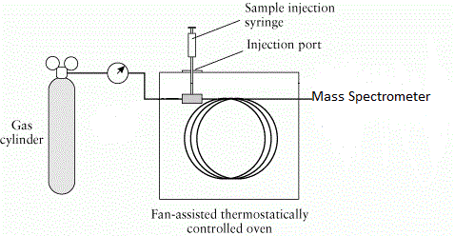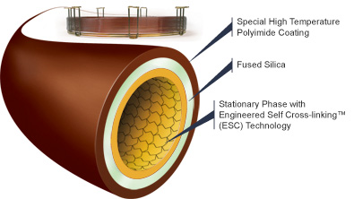
Figure 1: Diagram of a gas chromatograph [source?] Figure 2: Column specialized for measuring BAC [source?]

Mass Spectrometry




Mass spectrometry is method for analysing the elements present in a sample based on the different masses of the atoms. The device consists of an electron gun and electron trap, an electric field, an electromagnet, a detector, an amplifier and a chart recorder (see Figure 3). A vaporised sample is first inserted into tube in which it encounters an electron gun, this fires high energy electrons or ultraviolet light at the sample and as the high energy electrons pass through the sample they collect all the electrons from the sample, attracting them to the electron trap [source?]. Now that the atoms are all positively charged ions they pass through an electric field which causes them to rapidly accelerate so they all have the same kinetic energy and they are in a finely focused beam [source?]. They accelerate because they are repelled away from the very positive ionisation chambers (see Figure 4) (Smith, Davis, Disney, Hayes & Whan, 2014). The positive beam then travels through an electromagnet and undergoes deflection, the different ions deflect for 2 reasons; 1- the mass of the ion and 2- the charge of the ion. The ions with the most mass and the lowest positive charge will deflect the least so let’s say stream C, stream A will consist of ions with the lowest mass and highest positive charge, stream B will be the ions with just the right balance of both and flow straight through to the detector (see Figure 5) (Clark, n.d.). When Stream B reaches the detector it collides with a metal in which they pick up electrons and become neutralised, this happens by and electron jumping from a metal wire to the ion and then the other electrons in the wire move along taking the previous electrons spot this flow of electrons is then read as an electric current and the more ions that arrive the greater the current. This electric current is then amplified and recorded, as a mass spectrum, showing the different particles that passed through the detector (Chemguide.co.uk, 2015). Now to find the ions in stream A all you would have to is use a magnet that isn’t as strong and to find C, use a stronger magnet.
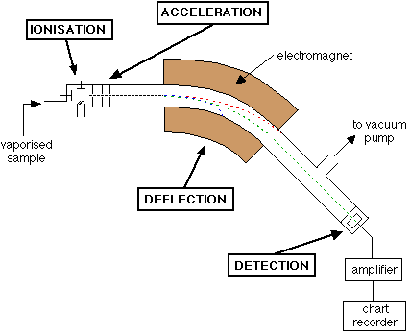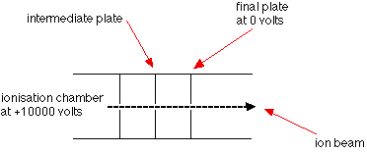
Figure 3: Schematic of a Mass Spectrometer [source?] Figure 4: Electric field (ionisation Chambers)
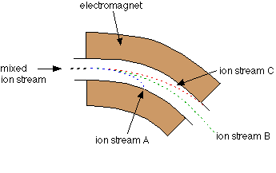
Figure 5: Deflection of ions as they pass between the electromagnet [source?]
Most of the data that is recorded from the mass spectrometer comes out as a stick graph, with the relative abundance or relative intensity on the y-axis and the mass to charge ratio on the x- axis (see Figure 6). The y-axis is related to the current recorded by the device, and the higher the current is, the more abundant the ion is from the sample. The mass to charge ratio is measured on the carbon-scale so say the ions all had a charge of positive one the scale would be like the one below in figure 6, and you can change it for purpose of use, so you can use it to find different things.
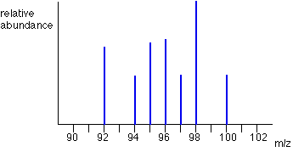
Figure 6: mass spectrum graph [source?]
Mass chromatography can be used to find a great number of different things such as detecting traces of chemical explosives, find pesticides in foods and detecting banned drugs in urine samples.
Detecting Cannabis (THC) in Urine Samples Using GC-MS

First of all you need to know what you are looking, so the correct metabolites. There are two metabolites in Cannabis, the main one is 11-nor-9-carboxy-THC (THC-COOH) and the second is 11-hydroxy-THC (Wikipedia, 2015). Using GC-MS, you would want to look for the main metabolite. The reference chart I have supplied below shows what you need to look for in a urine sample to identify the use of cannabis (see Figure 7). (See Figure 8) I have supplied an image showing the change in structure from the original drug (Delta-9-THC) to its main metabolite (THC-COOH).

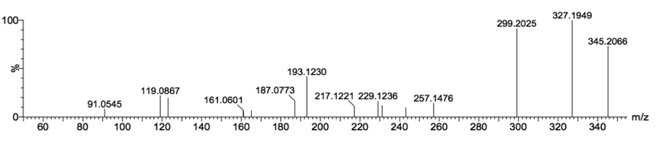
Figure 7: Reference Chart of (THC-COOH) [source?]
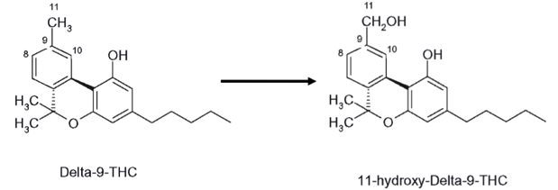
Figure 8: the structural change of THC to THC-COOH [source?]
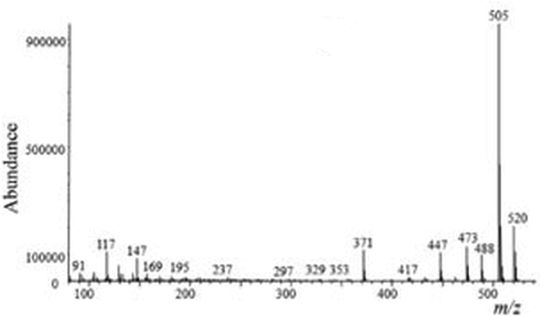
Figure 9: Mass Spectrum of a Urine sample [source?]
Once the urine sample has been inserted into the injection point it is heated into gas and then is injected into the column in which it is kept at a controlled temperature between 40ºc and 320ºc while being pushed by an inert gas, during this phase the chemical compounds are separated based on volatility, into molecules. After this has happened the molecules flow in to the mass spectrometer. First the fully vaporised sample of urine encounters an electron, which bombards it with high energy electrons or ultraviolet light, the electrons from the sample are then collected by the electron gun, and this is the process of ionisation. The positive ions are then forced through and electric field and are rapidly accelerated into appositive beam. They then encounter an electromagnet which deflects the ions according to their mass to charge ratio and are read by the detector at the end and displayed on a computer as a mass spectrum (see Figure 9)
To find the presence of THC-COOH in the mass spectrum of the urine sample you need compare it to the peaks on the reference chart, as one of the peaks will resemble a fragment broken off the metabolite (see Figure 8) during the ionisation phase of the GC-MS procedure. See as the metabolites undergo ionisation they break so parts of the hexagonal shapes (see Figure 8) separate. The different peaks on the reference chart (Figure 7) show different things you need to look for, if you want to know if the person has consumed cannabis. This procedure is an important one to use to find any banned drugs in a urine sample, because it can use a very little amount of fluid.
Conclusion
Gas chromatography and mass spectrometry is a fairly simple concept to grasp. It is also ideal for different practical applications such as what was just talked about, detecting banned drugs in urine samples. As you can see in the applied example all parts of this device play a role in what you are looking for. If you put the device into practice properly all results turned over by it will be accurate and reliable.

-Mitchell Gregory

Bibliography
Barbosa, S., Leal, F., Padilha, M., Silva, R., Pereira, H., Aquino Neto, F., & Silva JÃºnior, A. (2012). Specificity and selectivity improvement in doping analysis using comprehensive two-dimensional gas chromatography coupled with time-of-flight mass spectrometry. QuÃm. Nova, 35(5), 982-987. doi:10.1590/s0100-40422012000500022
Chemguide.co.uk,. (2015). the mass spectrometer - how it works. Retrieved 25 March 2015, from http://www.chemguide.co.uk/analysis/masspec/howitworks.html
Chemwiki.ucdavis.edu,. (2015). Gas Chromatography - Chemwiki. Retrieved 25 March 2015, from http://chemwiki.ucdavis.edu/Analytical_Chemistry/Instrumental_Analysis/Chromatography/Gas_Chromatography
Clark, J. How the Mass Spectrometer Works. UC Davis Chemwiki. Retrieved 25 March 2015, from Chemguide.co.uk,. (2015). the mass spectrometer - how it works. Retrieved 25 March 2015, from http://www.chemguide.co.uk/analysis/masspec/howitworks.html
Smith, D., Davis, A., Disney, A., Hayes, V., & Whan, R. (2014). Nelson Chemistry Units 1 & 2 for the Australian Curriculum (pp. 289-297). Cengage Learning.
Studyhplc.com,. (2015). The Chromatographic Principle. Retrieved 25 March 2015, from http://www.studyhplc.com/thechromatographicprinciple.php
Unsolvedmysteries.oregonstate.edu,. (2015). GCMS - How Does It Work? | Unsolved Mysteries of Human Health | Oregon State University. Retrieved 25 March 2015, from http://unsolvedmysteries.oregonstate.edu/MS_05
Wikipedia,. (2015). Drug metabolism. Retrieved 25 March 2015, from http://en.wikipedia.org/wiki/Drug_metabolism
Wikipedia,. (2015). Drug test. Retrieved 25 March 2015, from http://en.wikipedia.org/wiki/Drug_test

CONTENT
Aspect | 0 marks | 2 marks | 4 marks | 6 marks
How the instrument works | Describes a general principle of how machine works but lacks many details | A diagram shows the parts of the instrument and some information is given about what the different parts of the instrument do. | A diagram shows the function of the machine and information is given about the role of different parts of the instrument. Some description of chemical principles underpinning how the machine works using appropriate terminology (e.g. emission and absorption for AAS, elution and retention for GC-MS) | The function of each part is clearly described with details that show a level of research (i.e. not just paraphrased from textbook). Gives elaborate background into the chemical principles relevant to the analytical method (e.g. energy levels and absorption spectra for AAS, chromatographic principles for GC, etc.)
How data from the instrument is used | No explanation of how the output from the machine is used | Describes the type of output generated by the instrument. | Describes how the output of the instrument can be used to analyse, identify or detect substances and includes an appropriate image/table. | Explains how the results are used to analyse, identify or detect substances. Includes example AAS data or GC-MS data and demonstrates how this would be used for the particular application described.
Description of application | Lists the chosen application | Explains the importance of the chosen application. | Explains the importance of the chosen application and describes the chemistry of the substances which need to be analysed. | PART 2: ASSIGNMENT  Content = 15 / 16  Communication = 4.5 / 8  Total = 19.5 / 24  This will be combined with your mark in the validation test to achieve a total score /100.

COMMUNICATING THROUGH ACADEMIC WRITING:
Aspect | 0 marks | 1 mark | 2 marks
References list | - | Most references are correctly formatted using APA. Occasional minor problems. | All references correctly formatted using APA. No errors in referencing details.
In-text citations | - | Some attempt to use in-text citations but some parts are missing citations. | All information that is not common knowledge is attributed using a form of in-text citations.
Sources | - | At least three sources are used including at least one text source.
Conventions for figures and tables | - | Includes at least one figure or table. All figures and tables are labelled, include captions and sources, and are referenced in the main text.  OVERALL COMMENTS:  Your content was generally good but could have used editing and refining to reduce duplication of ideas between the sections.  The main problem was the lack of in-text referencing. Everywhere I wrote “[source?]” should have had a reference, including all images. This is vital to start doing in research assignments.
Headings | - | Divides report into logical sections using headings.
Writing | - | High quality presentation of writing with minimal spelling or grammar errors

